**SOFTWARE DEVELOPMENT**

Data Modeling for Place Rush Order

1. **Conceptual Data Model**

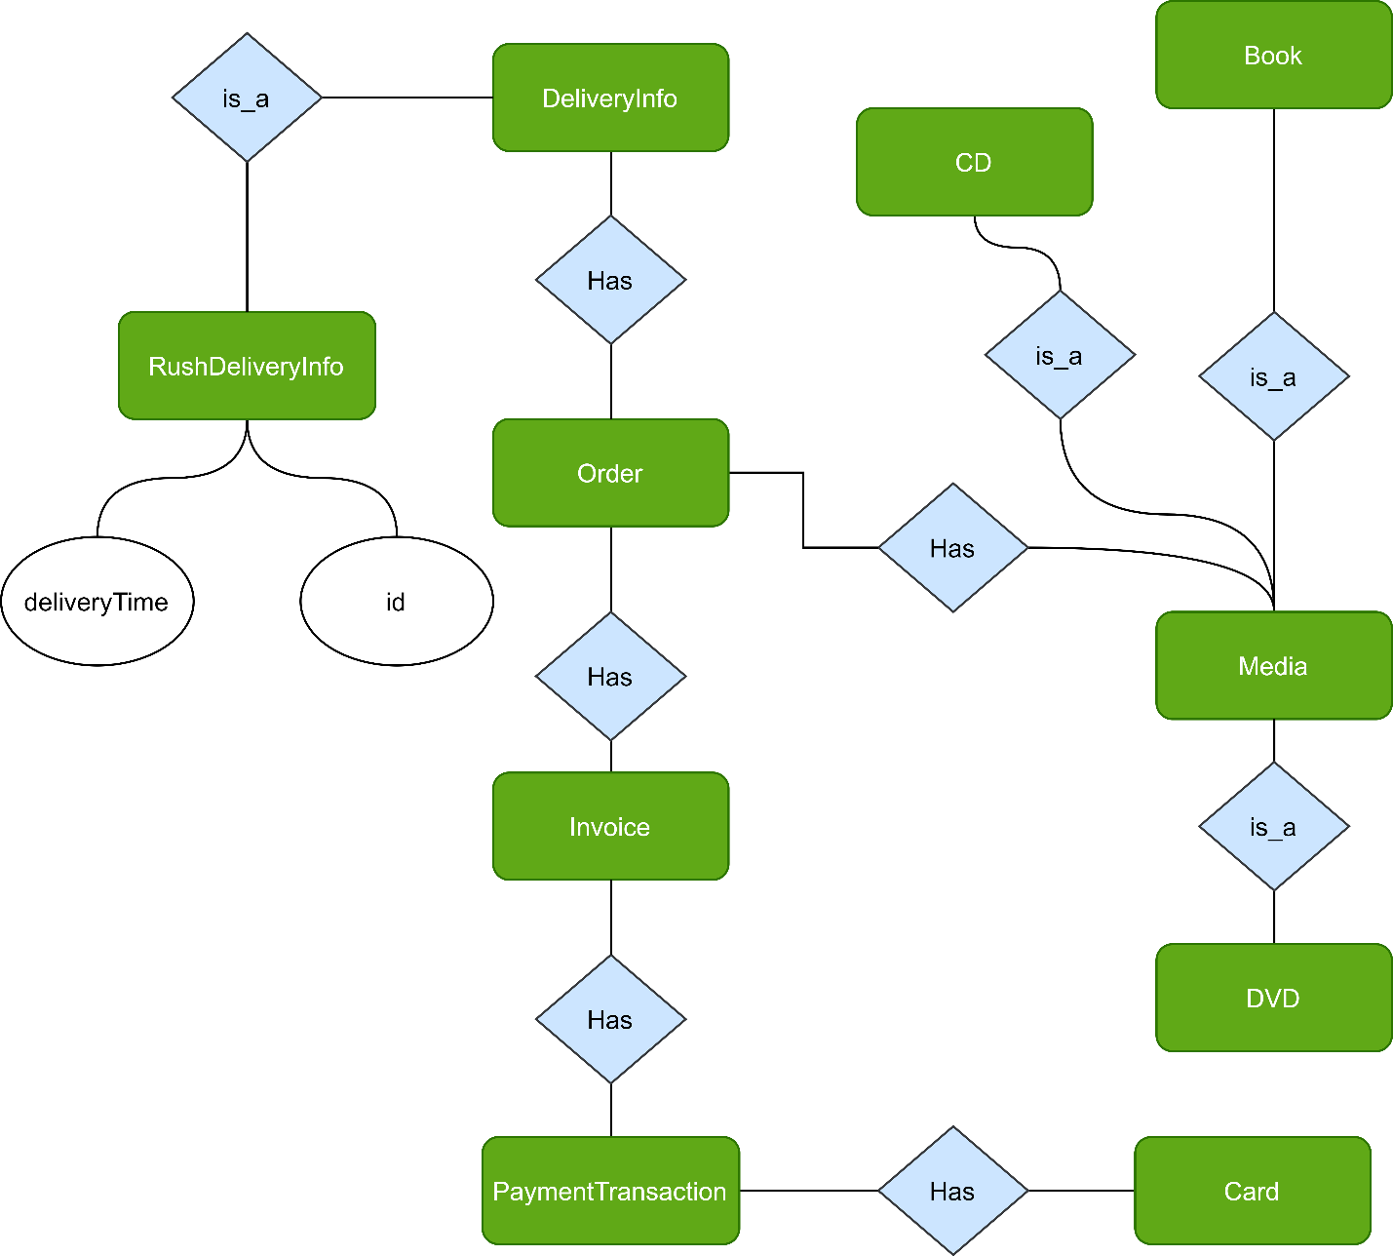

*Figure1. ER Diagram*

Add new entity ***RushDeliveryInfo*** with attribute ***id*** and ***deliveryTime***

1. **Logical Data Model**

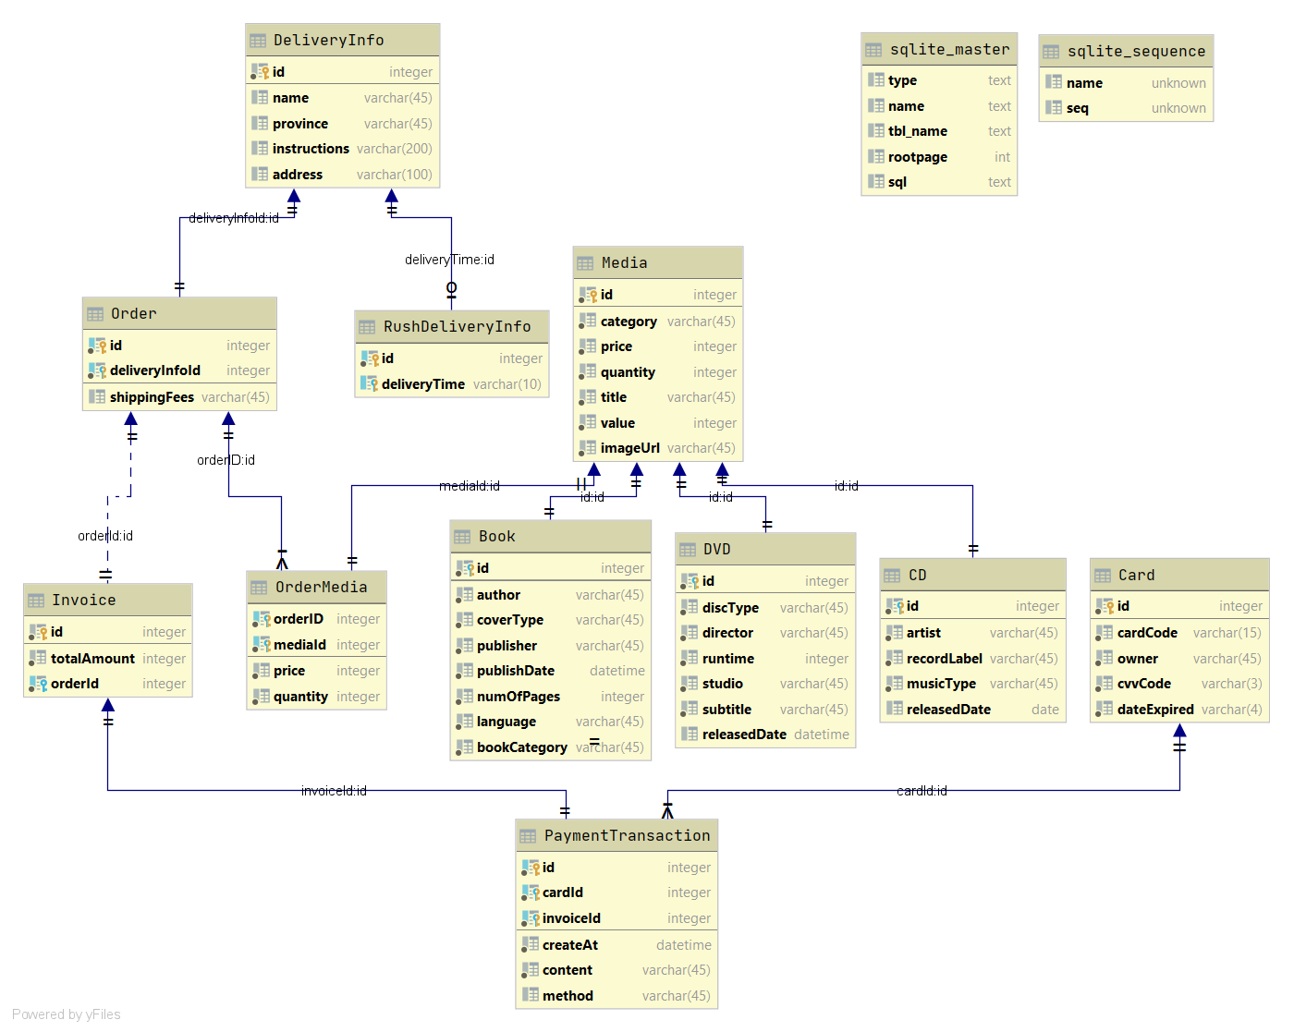

*Figure2. Relational Diagram*

Create new table ***RushDeliveryInfo*** with Primary key (***id***, ***deliveryTime***),

Foreign key ***id*** references ***DeliveryInfo*** (***id***)

1. **Physical Data Model**

* **RushDeliveryInfo**

|  |  |  |  |  |  |  |
| --- | --- | --- | --- | --- | --- | --- |
| # | PK | FK | Column name | Data type | Mandatory | Description |
| 1 | x | x | id | Integer | Yes | ID, same as ID of  DeliveryInfo which  type is Rush Order |
| 2 | x |  | deliveryTime | Varchar(10) | Yes | Delivery time which Customer requested |

* **Database script**

CREATE TABLE "RushDeliveryInfo"(

"id" INTEGER NOT NULL,

"deliveryTime" VARCHAR(10),

PRIMARY KEY("id","deliveryTime"),

CONSTRAINT "fk_Rush_DeliveryInfo" FOREIGN KEY("deliveryTime") REFERENCES "DeliveryInfo"("id")

);